1. **Compare** intermolecular forces and intramolecular forces. Give examples of each.

While intermolecular forces are attraction forces that exist between molecules, intramolecular forces are the bonds within a molecule. Examples of intermolecular forces are:

1. *Dispersion forces:* Attraction between the protons in a nucleus to the electrons in other molecules. Dispersion forces are experienced by all molecules.
2. *Dipole-dipole forces:* Dipole moments in polar molecules caused by electronegativity differences, the δ⁺ and δ⁻ poles are attracted to each other.
3. **Contrast** hydrogen bonding, dipole-dipole forces, and van der Waals forces.
4. Order the following from strongest (requires more energy to break molecules apart) to weakest: *covalent bonds, van der Waals forces, ionic bonds, hydrogen bonding, dipole-dipole forces*

Weakest Strongest

1. **Determine** which type/s of intermolecular force/s would exist between the following molecules.

*Hint: Determine the chemical formula. Draw the Lewis structure and determine the shape using VSEPR. Identify polar and non-polar bonds within the molecule. Use this information to identify the type/s of intermolecular force/s.*

* 1. Carbon tetrachloride
  2. Carbon dioxide
  3. Ammonia
  4. Hydrochloric acid
  5. Hydrofluoric acid
  6. Water

1. **Draw** a diagram of sodium chloride dissolved in water. Use dotted lines to show any intermolecular forces that are involved in the dissolution of sodium chloride.
2. **Compare** the structures of Vitamin A and Vitamin C. **Determine** which vitamin would be more soluble in water, based on its chemical structure.

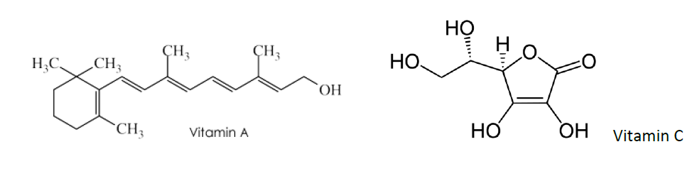

1. Octane (C8H18) is a saturated hydrocarbon which is commonly used in petrol. **Predict** what would happen if 0.5L of octane was mixed with 0.5L of water. In your response, **explain** the intermolecular forces that are involved in this interaction. You may use a diagram to support your response.